**Casting:**

**Two types:**

**Unicast:** sending packets from one host to other is called unicast

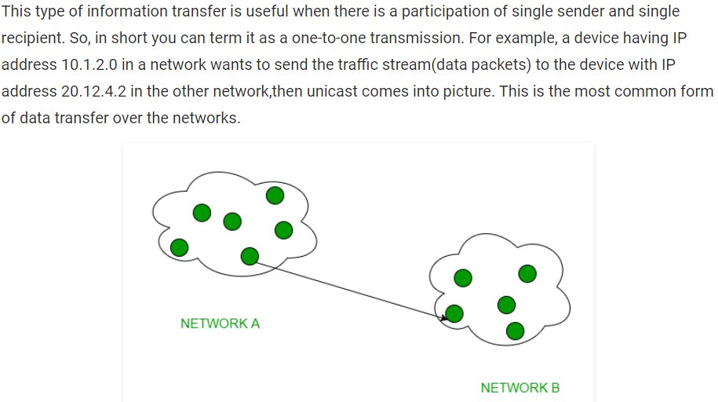

**Broadcast:** sending packets from one host to many is called broadcast

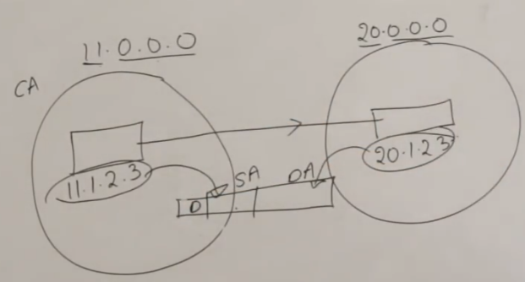

* Broadcasting is again two types
* One is limited broadcasting and other is directed broadcasting

**Limited BroadCasting:**

* If we want to send packets from one host to all inside a network is called limited broadcasting
* There is a problem as it sends to all the hosts inside the network
* It means a host wants to send package to all the other hosts inside the same network is called limited broadcasting

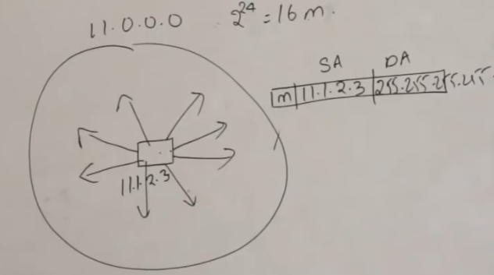

* As above, it wants to send packets to all hosts. So, it takes all 1 for 32 bits. So, we it will be as 255.255.255.255
* If it all 255 as above, it sends the packets to all inside the same network

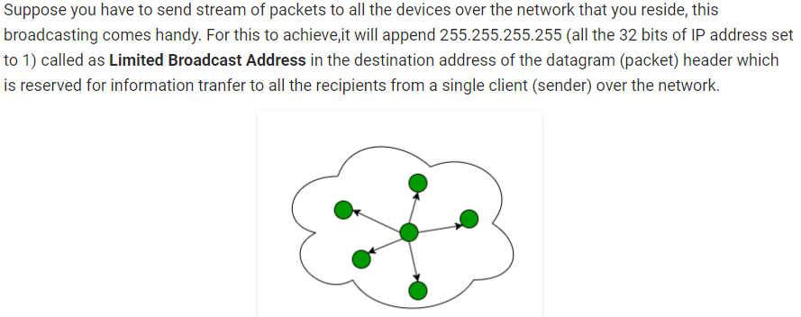

**Direct Broadcasting:**

* Directed broadcasting is to send the packet from one host to all in another network
* As below, if we give destination IP as 20.255.255.255, it will send the packets to all hosts inside the network

